DEPARTMENT OF LAND REFORM & RURAL DEVELOPMENT
SECURITY SERVICE PORTAL
Internal Unit Testing Document
Module: Security Coordinator User Type
Tester: Lebogang Dire
Date: 04 August 2026
Environment: Development / Test
Build Version: v1.0 (or current version)

Test Cases
Test Case SEC-001
LOGIN
Field | Details
Test Case ID | EMP-001
Module | Login
Feature | Security Coordinator Login
Requirement | Security Coordinator should successfully log into the system.
Preconditions | Security Coordinator account exists and is active.
Test Data | Spelling & Naming Convention
Steps | - Open Login page.  - The correct naming is as follows:  DEPARTMENT OF LAND REFORM & RURAL DEVELOPMENT (DLRRD)  - Security Incident Management System (SIMS)
Expected Result | The naming of the system should adhere to the BRS document/ Company CI
Actual Result | Dashboard loaded correctly.
Status Pass | Fail
Severity | Low
Screenshot | 
Time | 9:46

Field | Details
Test Case ID | SEC-002
Module | Login
Feature | Role-Based Authentication
Requirement | Verify that the system automatically assigns the correct user role after successful authentication without requiring manual role selection.
Preconditions | Security Coordinator account exists and is active.
Test Data | Spelling & Naming Convention
Steps | 1. The system is running and accessible.  2. A valid user account exists (e.g., Security Coordinator).  3. The user has been assigned a role in the system database.  4. User is on the login page.
Expected Result | Fail: The login page requires users to manually select a role (Employee, Security Coordinator, Chief Investigator, etc.) before signing in, which is inconsistent with role-based authentication.
Actual Result | Fail: The login page requires users to manually select a role (Employee, Security Coordinator, Chief Investigator, etc.) before signing in, which is inconsistent with role-based authentication.
Status Pass | Fail
Severity | Low
Screenshot | 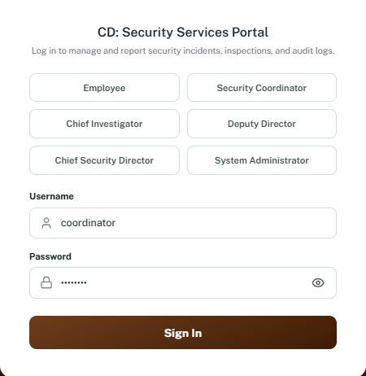
Time | 12:54

Field | Details
Test Case ID | SEC-002
Module | Login
Feature | Password Visibility Toggle
Requirement | Verify that the password visibility icon allows users to show and hide their password securely.
Preconditions | 1.User is on the Login page.  2. Password field is displayed.
Test Data | Password: Password@123
Steps | 1. Navigate to the Login page.  2. Enter a valid password in the Password field.  3. Verify that the password is masked by default.  4. Click the Eye (visibility) icon.  5. Verify that the password becomes visible.  6. Click the Eye icon again.  7. Verify that the password is hidden (masked) again.
Expected Result | The password should be masked by default. Clicking the visibility icon should display the password in plain text, and clicking it again should mask the password.
Actual Result | Fail: The password visibility icon is misaligned within the Password field. It is not vertically aligned with the password text, resulting in an inconsistent and unprofessional user interface.
Status Pass | Fail
Severity | Low
Screenshot | 
Time | 13:06

Field | Details
Test Case ID | DASH-001
Module | Dashboard
Feature | Severity Distribution Chart
Requirement | Verify that the severity distribution chart displays data using an appropriate and readable Y-axis scale.
Preconditions | User is logged in and the dashboard has loaded.
Test Data | Existing incident records.
Steps | 1. Log into the system.  2. Navigate to the Dashboard.  3. View the Severity Distribution – Gauteng chart.  4. Observe the Y-axis scale and chart representation.
Expected Result | The Y-axis should start at an appropriate baseline (typically 0) and clearly represent the incident counts for each severity level.
Actual Result | Fail: The Y-axis starts at 14 instead of 0, making the chart difficult to interpret and potentially misleading.
Status Pass | Fail
Severity | Medium
Screenshot | 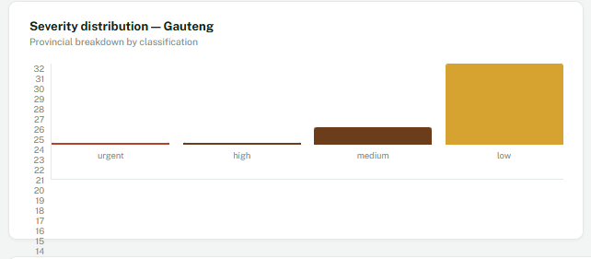
Time | 13:26

Field | Details
Test Case ID | DASH-002
Module | Dashboard
Feature | Recent Incident – Place Column
Requirement | Verify that the Place column displays valid, complete, and standardized incident locations.
Preconditions | User is logged in and the dashboard is displayed.
Test Data | Existing incident records.
Steps | 1. Log into the system.  2. Navigate to the Dashboard.  3. Open the Recent Incident – Gauteng table.  4. Review the values displayed in the Place column.
Expected Result | The Place column should display complete and valid incident locations for all records in a consistent format (e.g., Building, Floor, Room, City). Placeholder or test values should not be displayed.
Actual Result | The dashboard correctly displays the location values stored for each incident record.
Status Pass | Pass
Severity | N/A
Screenshot | 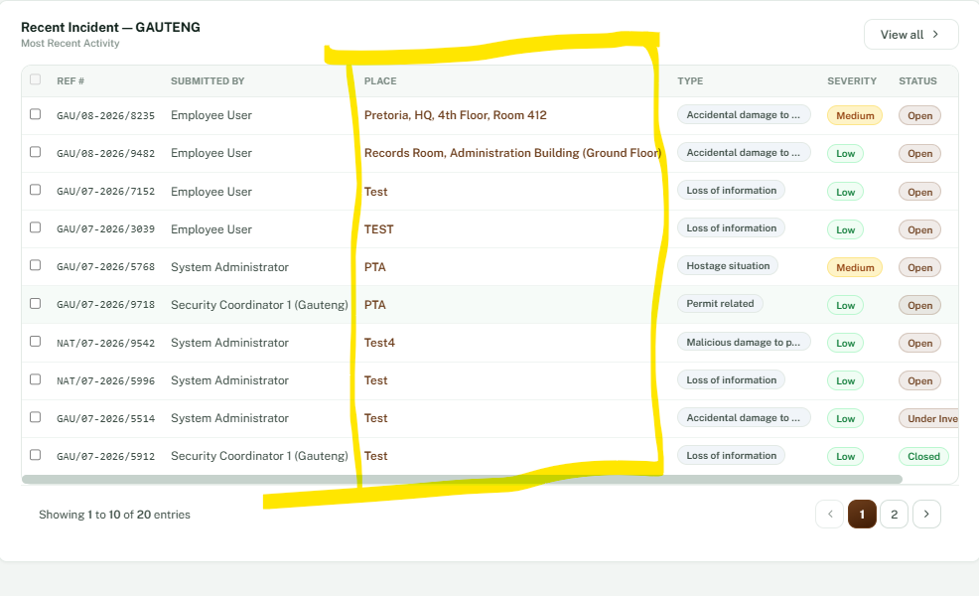
Time | 13:28

Field | Details
Test Case ID | DASH-003
Module | Dashboard
Feature | Incident Record Selection
Requirement | Verify that users can select incident records using the checkboxes.
Preconditions | User is logged in and the dashboard is displayed.
Test Data | Existing incident records.
Steps | 1. Log into the Security Incident Management System (SIMS).  2. Navigate to the Dashboard.  3. Locate the Recent Incident – Gauteng table.  4. Click the checkbox next to an incident record.  5. Verify that the checkbox changes to the selected state.  6. Observe whether the selected row is highlighted.  7. Observe whether any bulk action buttons or contextual actions become available after selecting the record.
Expected Result | Selecting one or more incident records should activate the intended functionality, such as enabling bulk actions or performing another system-defined action.
Actual Result | Fail: The incident records can be selected; however, selecting the checkboxes does not trigger any action or enable any additional functionality.
Status Pass | Fail
Severity | Medium
Screenshot | 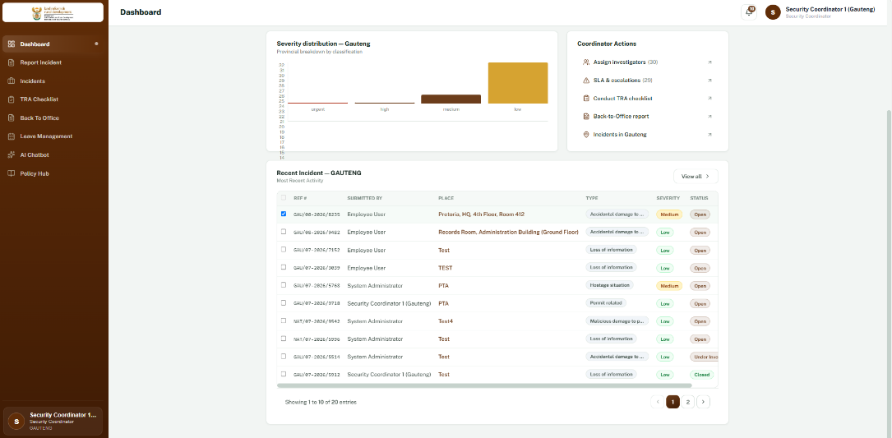
Time | 13:37

Field | Details
Test Case ID | NAV-002
Module | Breadcrumb Navigation
Feature | View Case Breadcrumb
Requirement | Verify that the breadcrumb navigation accurately reflects the user's navigation path without redundant entries.
Preconditions | User is logged in and has opened an incident case.
Test Data | Existing incident reference (e.g., NAT/07-2026/9542).
Steps | 1. Log into the system.  2. Navigate to the Dashboard.  3. Open an incident case.  4. Observe the breadcrumb navigation.
Expected Result | The breadcrumb should display a clear and meaningful navigation path. If Home and Dashboard point to the same page, only one should be displayed to avoid redundancy (e.g., Dashboard > NAT/07-2026/9542 or Home > NAT/07-2026/9542).
Actual Result | Fail: The breadcrumb displays both Home and Dashboard, even though they navigate to the same page, resulting in redundant navigation.
Status Pass | Fail
Severity | Low
Screenshot | 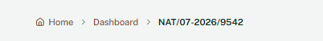
Time | 13:48

Field | Details
Test Case ID | NOTIF-001
Module | Notifications
Feature | Notification Badge Count
Requirement | Verify that the notification badge accurately displays the number of unread notifications.
Preconditions | User is logged into the system and has unread notifications.
Test Data | Existing unread notifications.
Steps | 1. Log into the Security Incident Management System (SIMS).  2. Observe the notification badge count displayed on the bell icon.  3. Click the notification bell to open the notification panel.  4. Count the number of unread notifications displayed.  5. Compare the unread notification count with the badge count.
Expected Result | The notification badge should accurately reflect the total number of unread notifications displayed in the notification panel.
Actual Result | Fail: The notification badge count does not match the actual number of unread notifications displayed in the notification panel.
Status Pass | Fail
Severity | Medium
Screenshot | 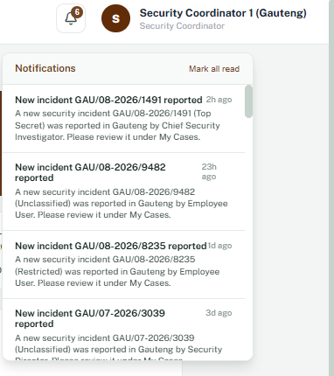
Time | 13:56

Field | Details
Test Case ID | UI-005
Module | Case Management
Feature | Case List Table Alignment
Requirement | Verify that all table columns and content are consistently aligned according to the approved UI design.
Preconditions | User is logged in and has navigated to the Case Management page.
Test Data | Existing case records.
Steps | 1. Log into the system.  2. Navigate to the Case Management page.  3. Observe the alignment of the table headers and row content.  4. Compare the layout with the approved UI design.
Expected Result | All table headers, text, badges, and action buttons should be consistently aligned with uniform spacing throughout the table.
Actual Result | Fail: The table contains alignment inconsistencies. Some columns and content are not vertically aligned, resulting in an uneven and inconsistent appearance.
Status Pass | Fail
Severity | Low
Screenshot | 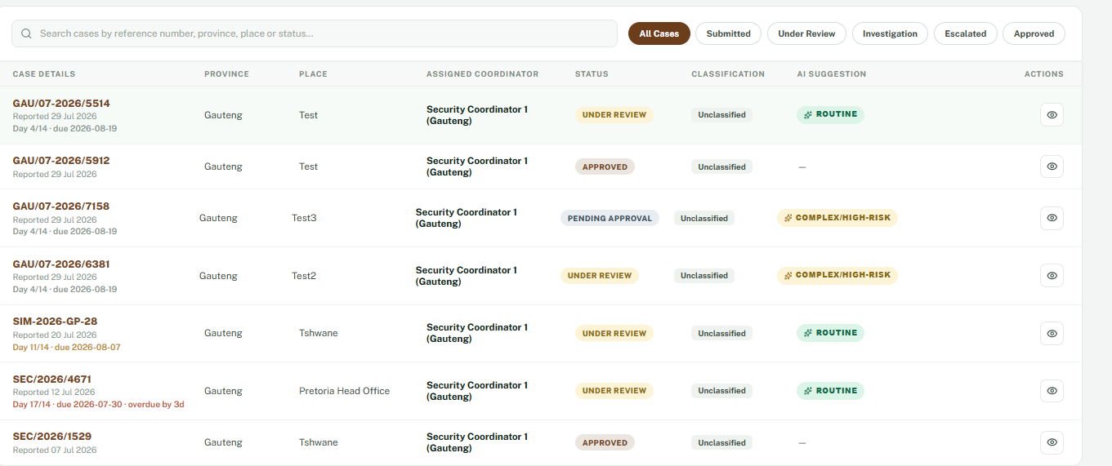
Time | 14:56

Field | Details
Test Case ID | PERF-005
Module | Submit Security Reports
Feature | Incident Report Submission
Requirement | Verify that the system submits the incident report and uploads supporting documents within the acceptable response time.
Preconditions | 1. User is logged into the system.  2. All mandatory fields have been completed.  3. A valid supporting document has been attached.
Test Data | Completed incident report with a valid attachment (e.g., Testing Case.docx).
Steps | 1. Log into the system.  2. Navigate to the Case Management page.  3. Observe the alignment of the table headers and row content.  4. Compare the layout with the approved UI design.
Expected Result | The incident report and supporting document should be submitted successfully within the acceptable response time. The system should display a confirmation message with a generated reference number.
Actual Result | Fail: After clicking Submit, the system remained in the "Submitting & Uploading..." state for longer than the acceptable response time before completing the submission.
Status Pass | Fail
Severity | Medium
Screenshot | 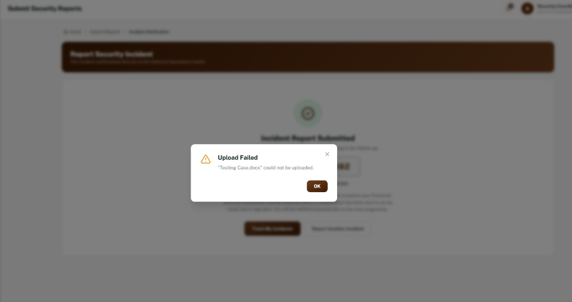
Time | 14:01

Field | Details
Test Case ID | PROF-002
Module | User Profile
Feature | Edit Profile
Requirement | Verify that users can edit their profile information after clicking the Edit Profile button.
Preconditions | 1. User is logged into the Security Incident Management System (SIMS).  2. User has navigated to the Profile page.
Test Data | Updated phone number (e.g., 012 312 9999) or other editable profile information.
Steps | 1. Log into the system.  2. Navigate to the Profile page.  3. Click the Edit Profile button.  4. Attempt to edit the editable profile fields (e.g., Phone Number).  5. Click Save Changes if the fields become editable.
Expected Result | Clicking Edit Profile should enable the editable fields, allowing the user to update their profile information and save the changes successfully.
Actual Result | Fail: After clicking Edit Profile, the profile fields remained read-only and could not be edited. No changes could be made to the profile information.
Status Pass | Fail
Severity | High
Screenshot | 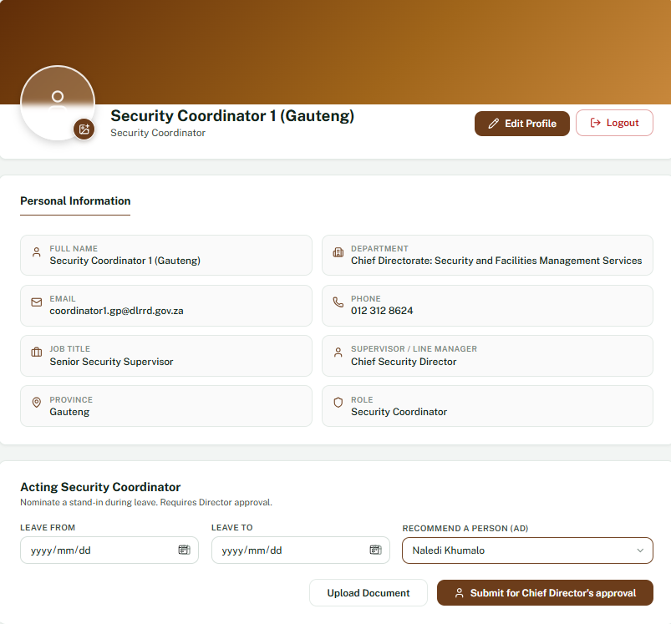
Time | 14:55

Field | Details
Test Case ID | NAV-003
Module | User Profile
Feature | Breadcrumb Navigation
Requirement | Verify that the breadcrumb navigation accurately reflects the user's location without redundant entries.
Preconditions | User is logged into the Security Incident Management System (SIMS).
Test Data | N/A
Steps | 1. Log into the system.  2. Navigate to My Profile.  3. Observe the breadcrumb displayed at the top of the page.  4. Verify that each breadcrumb item represents a unique navigation level.
Expected Result | The breadcrumb should display a clear navigation hierarchy without duplicate or redundant page names. For example: Home > My Profile or Home > Profile.
Actual Result | Fail: The breadcrumb displays Home > My Profile > Profile, where My Profile and Profile represent the same page, resulting in redundant navigation.
Status Pass | Fail
Severity | Low
Screenshot | 
Time | 14:55

Field | Details
Test Case ID | FILE-002
Module | User Profile
Feature | Upload Document
Requirement | Verify that users can upload a supporting document for the Acting Security Coordinator nomination.
Preconditions | 1. User is logged into the Security Incident Management System (SIMS).  2. User has navigated to the My Profile page.  3. The Acting Security Coordinator section is displayed.
Test Data | Valid supporting document (e.g., SupportingDocument.pdf or Testing Case.docx).
Steps | 1. Log into the system.  2. Navigate to My Profile.  3. Scroll to the Acting Security Coordinator section.  4. Click the Upload Document button.  5. Select a valid document.  6. Confirm the upload.
Expected Result | Clicking the Upload Document button should open the file browser, allow the user to select a supported file, and successfully attach the document.
Actual Result | Fail: Clicking the Upload Document button does not open the file browser or allow a document to be selected. No upload action is performed.
Status Pass | Fail
Severity | Low
Screenshot | 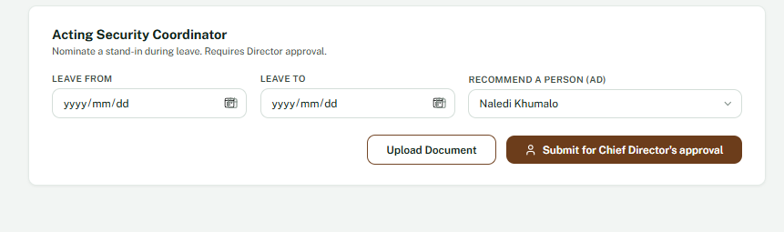
Time | 15:09

Field | Details
Test Case ID | LEAVE-001
Module | Leave Management
Feature | Leave Balance
Requirement | Verify that the user's available leave balance is displayed accurately.
Preconditions | Verify that the user's available leave balance is displayed accurately.
Test Data | User leave entitlement.
Steps | 1. Log into the system.  2. Navigate to Leave Management.  3. Observe the Leaves Available indicator.
Expected Result | The leave balance should display the correct number of available leave days.
Actual Result | Fail: Clicking the Request Leave button does not perform any action.
Status Pass | Fail
Severity | High
Screenshot | 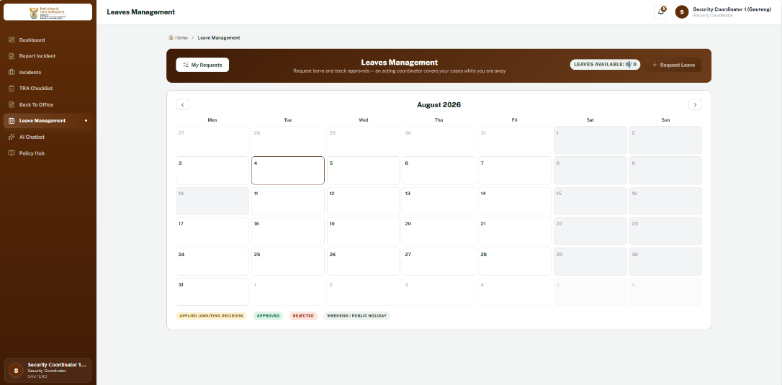
Time | 15;19

Field | Details
Test Case ID | LEAVE-001
Module | Leave Management
Feature | Leave Balance
Requirement | Verify that the user's available leave balance is displayed accurately.
Preconditions | Verify that the user's available leave balance is displayed accurately.
Test Data | User leave entitlement.
Steps | 1. Log into the system.  2. Navigate to Leave Management.  3. Observe the Leaves Available indicator.
Expected Result | The leave balance should display the correct number of available leave days.
Actual Result | Fail: Clicking the Request Leave button does not perform any action.
Status Pass | Fail
Severity | High
Screenshot | 
Time | 15;19

